**DBMS ASSIGNMENT 4**

**CLASS: TE B**

**ROLL NO: 322008**

**Problem Statement:** Design at least 10 SQL queries for suitable database application using SQL DML statements: all types of Join, Sub-Query and View.

**Screenshots:**

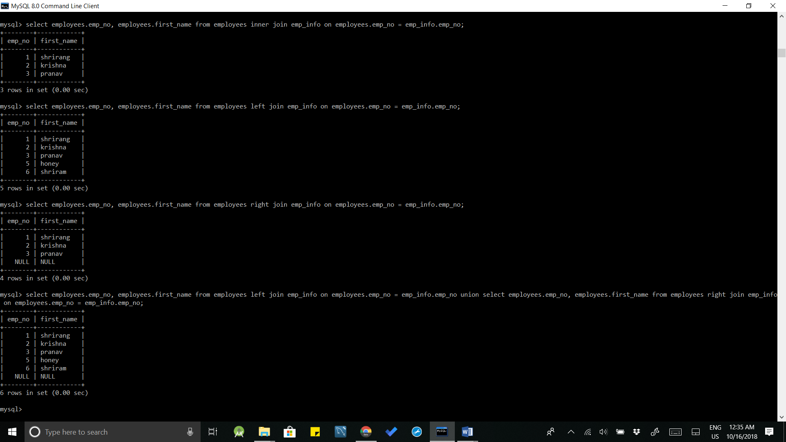

**Queries:**

1. Select employees.emp_no, employees.first_name from employees inner join emp_info on employees.emp_no = employees.emp_no;
2. Select employees.emp_no, employees.first_name from employees left join emp_info on employees.emp_no = employees.emp_no;
3. Select employees.emp_no, employees.first_name from employees right join emp_info on employees.emp_no = employees.emp_no;

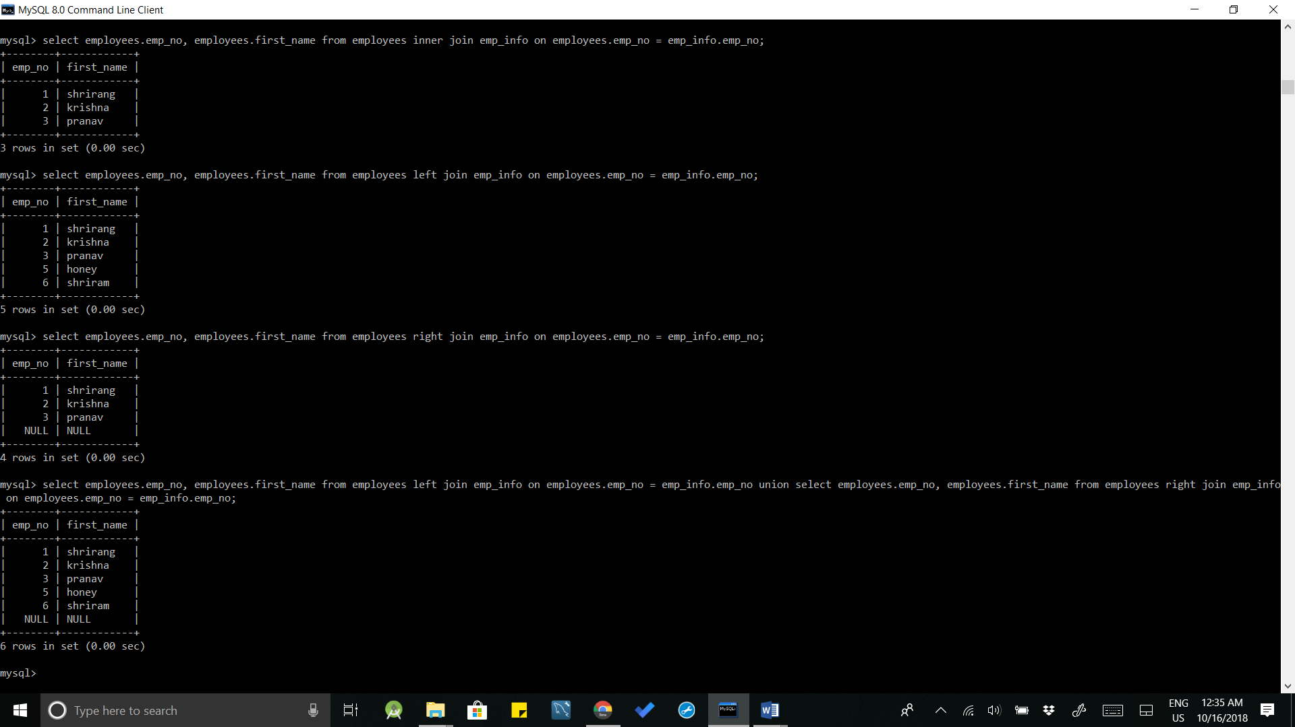

**Queries:**

1. Select employees.emp_no, employees.first_name from employees left join emp_info on employees.emp_no = employees.emp_no union Select employees.emp_no, employees.first_name from employees right join emp_info on employees.emp_no = employees.emp_no;

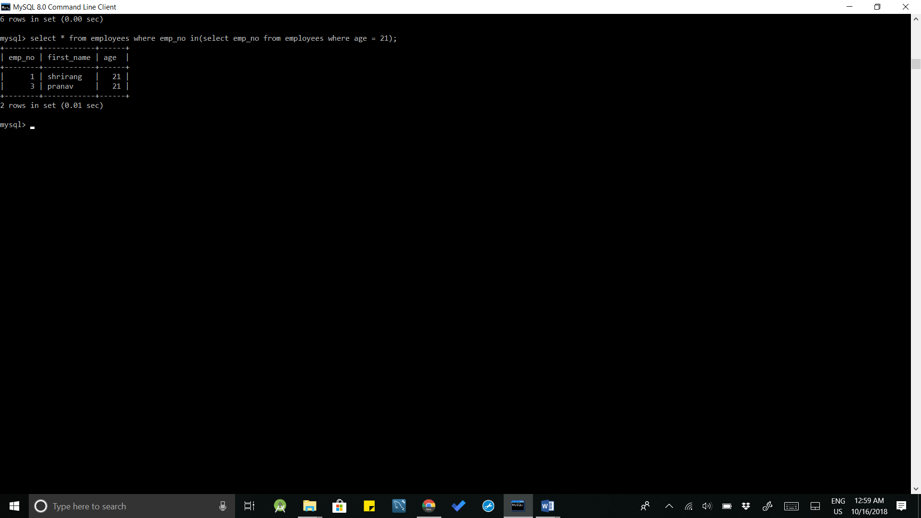

**Queries:**

1. Select * from employees where emp_no in(select emp_no from employees where age = 21);

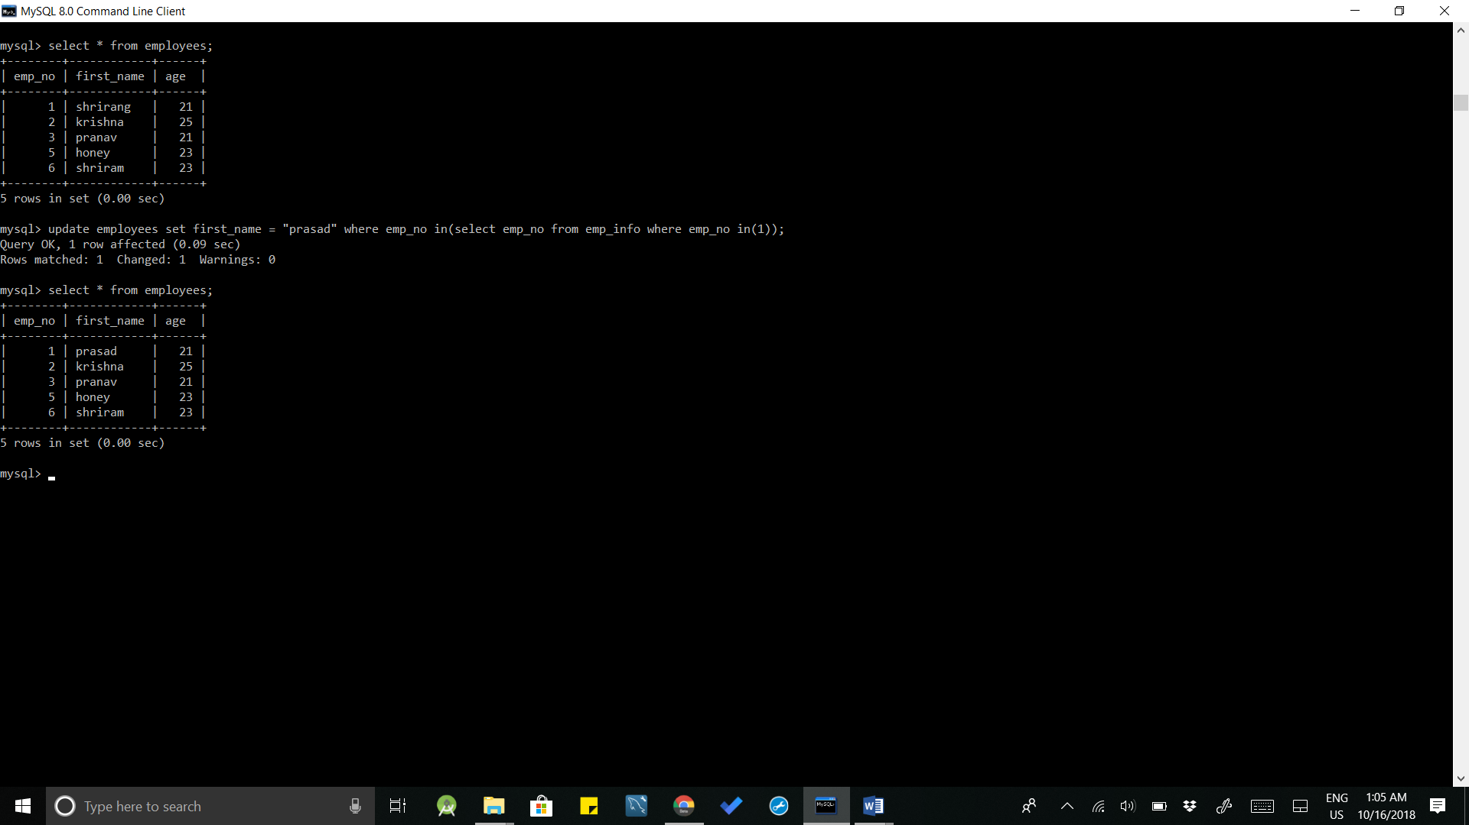

**Queries:**

1. select * from employees;
2. update employees set first_name = “prasad” where emp_no in(select emp_no from emp_info where emp_no in(1));
3. select * from employees;

**Conclusion:** 10 SQL queries using SQL DML statements: all types of Join, Sub-Query and View were successfully performed.